**Linear Regression Algorithm**

Linear regression algorithm is a supervised machine learning algorithm that supports finding the correlation between variables. It is used principally for prediction, forecasting, time series modelling and determining the relationship between variables.

The algorithm predicts values within a continuous range (e.g. sales price) rather than trying to classify them into categories (e.g. dog, cat). For example, economists are using linear regression algorithm to predict future market prices to make profit.

The representation is a linear equation that combines a specific set of input values (x) the solution to which is the predicted output for that set of input values(y):

x = a + b * x, where a and b are reel number.

The following chart is an example of predicting weight (y) from height (x):

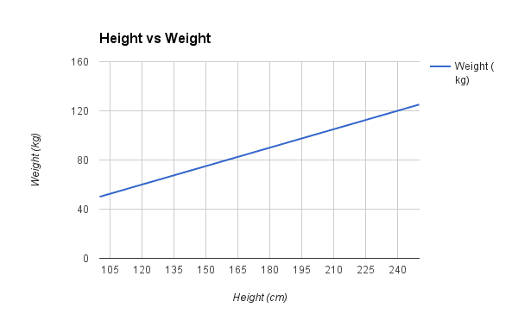There are two main types of linear regression: simple regression and multivariable regression.:

* Simple regression: it can be used to work out how much a company spends on Radio advertising each year and its annual Sales in terms of units sold. The idea is to try to develop an equation that will predict units sold based on how much a company spends on radio advertising.
* Multivariable regression can be used to try predicting blood pressure (the dependent variable) from independent variables such as height, weight, age, and hours of exercise per week.

**Logistic Regression Algorithm**

Logistic regression is a supervised classification algorithm used to assign observations to a discrete set of classes. It is a predictive analysis algorithm and based on the concept of probability. Therefore the outcome must be a categorical or discrete value. It can be either Yes or No, 0 or 1, True or False etc.but instead of giving the exact value as 0 and 1. It gives the probability values which lies between 0 and 1..

Some of the examples of classification problem are email spam or not spam, online transactions fraud or not fraud, tumour malignant or benign. Logistic regression transforms its output using the logistic sigmoid function to return a probability value.

***Y = 1 / 1+e -z***

There are two types of Logistic Regression:

* Binary (e.g. Tumour Malignant or Benign)
* Multi-linear functions (e.g. Cats or Dogs).

The assumptions made by logistic regression about the distribution and relationships in the data are much the same as the assumptions made in linear regression. The difference between these two algorithms is that linear regression is used for solving regression problems, whereas logistic regression is used for solving the classification problems.

In logistic regression. Instead of fitting a regression line, an “S” shaped logistic function is fitted, which predicts two maximum values (0 or 1).

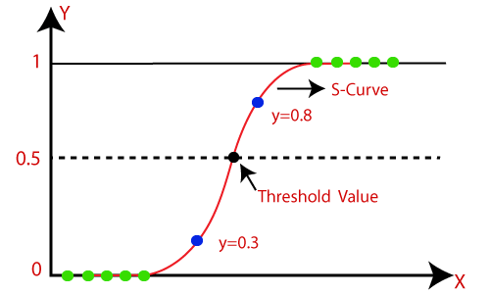

**Decision Tree Algorithm**

The decision tree algorithm belongs to the family of supervised machine learning algorithms. Unlike other supervised learning algorithms, the decision tree algorithm can be used for solving **regression and classification problems** too. The goal of using a decision tree is to create a training model that can use to predict the class or value of the target variable by **learning simple decision rules**inferred from training data. Decision trees are flexible models that don’t increase their number of parameters as more features are added. They can either output a categorical prediction (like if a plant is of a certain kind or not) or a numerical predication (like the price of a house).

The following figure shows a classification tree for a bank loan application for a customer.

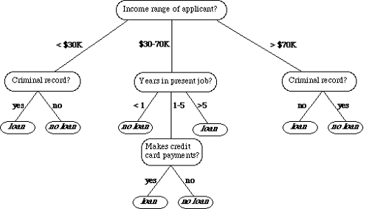

References

Naithani, S (2019), *What is Linear Regression Algorithm* [Online], [Accessed 13/08/2021]. Available at < https://in.springboard.com/ blog/what-is-linear-regression>.

Brownlee, J (2020), *Linear Regression for Machine Learning* [Online]. [Accessed 13/08/2021]. Available at <https://machinelearningmastery.com/ linear-regression-for-machine-learning>.

Gandhi, R (2018), *Learning Algorithms: Linear regression* [Online]. [Accessed 13/08/2021]. Available at <https://towardsdatascience.com/introduction-to-machine-learning-algorithms-linear-regression-14c4e325882a>.

Kambria (2021), *Logistic Regression For Machine Learning and Classification* [Online]. [Accessed 13/08/2021]. Available at <https://kambria.io/blog/logistic-regression-for-machine-learning>.

Sharma, A (20121), *Machine Learning 101*: *Decision Tree Algorithm for Classification.* [Online]. [Accessed 13/08/2021]. Available at <https://www.analyticsvidhya.com/blog/2021/02/machine-learning-101-decision-tree-algorithm-for-classification>.

Kumawat, D (2019), *Introduction to Logistic Regression – Sigmoid Function, Code Explanation* [Online]. [Accessed 13/08/2021]. Available at <https://www.analyticssteps.com/blogs/introduction-logistic-regression-sigmoid-function-code-explanation>.

Brownlee, J (2020), *Regression for Machine Learning* [Online]. [Accessed 13/08/2021]. Available at <https://machinelearningmastery.com//logistic-regression-for-machine-learning>.

Survana3 (2021), *Regression in machine learning* [Online]. [Accessed 13/08/2021]. Available at <https://www.analyticsvidhya.com//blog/2021/06/linear-regression-in-machine-learning>.